Lab Manual 3

- University Management System

  - Entities & Attributes

University → University_ID, Name
Department → Department_ID, Name
Student → Student_ID, Name, Email, Phone
Faculty → Faculty_ID, Name, Designation
Course → Course_ID, Course_Name, Credits
Enrollment (associative) → Enrollment_ID, Student_ID, Course_ID

  - Primary Keys

University → University_ID
Department → Department_ID
Student → Student_ID
Faculty → Faculty_ID
Course → Course_ID
Enrollment → Enrollment_ID

  - Relationships & Cardinality

University → Department → 1 : M
Department → Course → 1 : M
Department → Student → 1 : M
Faculty → Course → 1 : M
Student → Course → M : N (via Enrollment)

  - M:N Resolution
Student ↔ Course → resolved using Enrollment
Contains FK: Student_ID, Course_ID

  - ERD
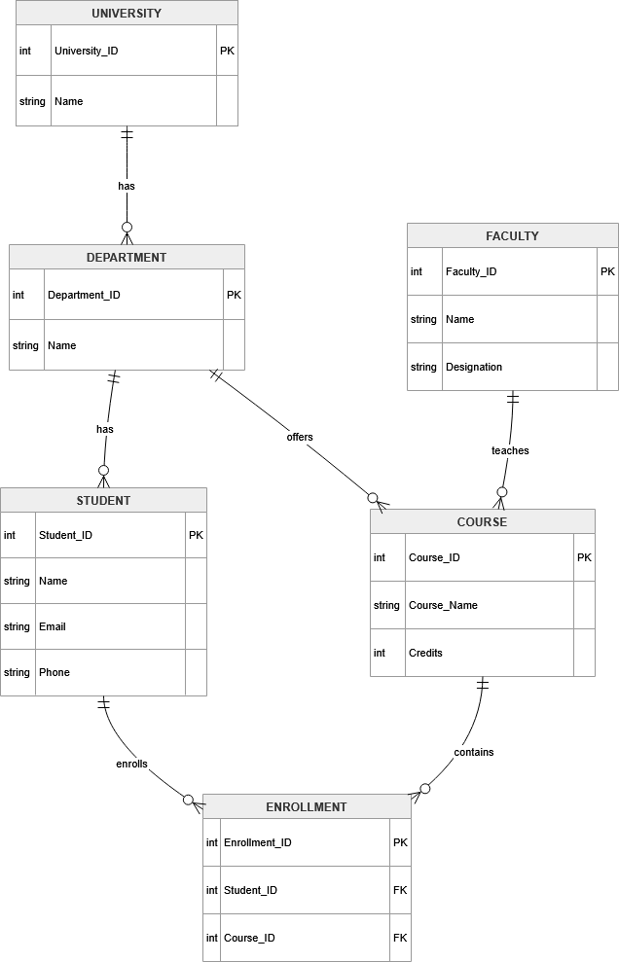

- Online Shopping System

  - Strong and Weak Entities

Strong Entities:
Customer, Order, Product, Category, Payment
Weak / Associative Entity:
Order_Item (depends on Order + Product)

  - Relationships & Cardinality

Customer → Order → 1 : M
Order → Product → M : N (via Order_Item)
Order → Payment → 1 : 1
Category → Product → 1 : M

  - M:N Resolution

Order ↔ Product → resolved using Order_Item
Attributes: Order_ID, Product_ID, Quantity

  - Participation Constraints

Customer → Order → Partial (customer may not order)
Order → Payment → Total (every order must have payment)
Order → Order_Item → Total
Product → Order_Item → Partial

  - ERD
